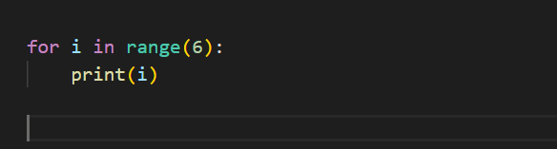

By default

1. The starting is from 0
2. Here the ending is at 6, but 6 excluded
3. And increment is +1 by default

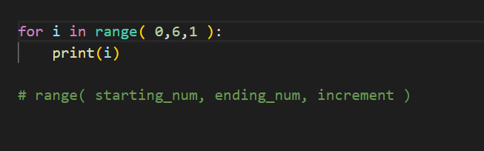

**There are different ways to work with function in python**

**Arbitrary Arguments, *args**

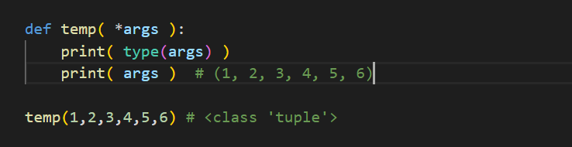

We can pass as many arguments and they can be accessed as tuple inside the function

**Keyword Arguments**

We can also pass the arguments in key = value pair

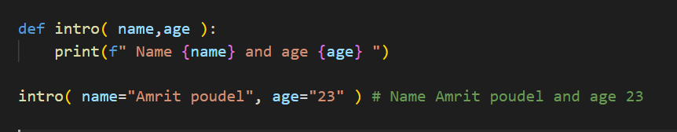

**Arbitrary Keyword Arguments, **kwargs**

We can pass as many key = value pair and those items can be accessed as a dictionary inside the function

